**DATABASE MANAGEMENT SYSTEM PROJECT**

**Mall Management Database system**

**TEAM:**

**Upre Ashish Kumar (21CSB0B62)**

**B. Bharadwaj (21CSB0B07)**

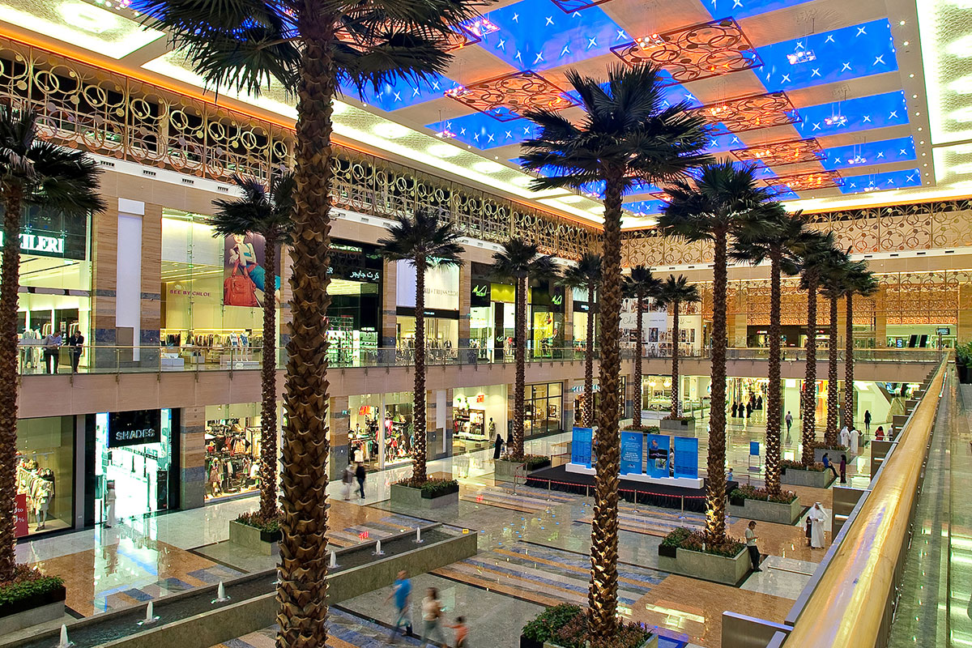

**PROBLEM STATEMENT:**

Shopping malls are fast becoming a central part of life all over the world.

Many malls are being constructed in all developing countries. However,

maintenance of malls is an important necessity. So, we have designed a

database to store information about all Malls in a particular city.

The database will be accessible to the administrator of the Malls

including their managers. It will be handled by Tenant Officers. Also, it

will contain all required information about different places around a Mall

like Shops of different categories, Movie Halls, Food corners, ATM and

Game zone. A separate management system relation along with opening

and closing time of Mall is also included. This database gives information

about all the Malls with reference to its Mall code in a city.

Through this database system we can manage maintenance of all the

shops and other places in a particular mall and also monitor all activities

of all Malls. Also, it enables the administrator to get information about

expenses and earnings of all the shops in a Mall which gets updated each

time after installment of any new activity with less time and less effort.

**CONTENTS:**

* **TABLES**
* **ER MODEL ASSUMPTIONS**
* **FUNCTIONAL DEPENDENCIES & PRIMARY KEY**
* **NORMALISATION**
* **ER DIAGRAM**
* **RELATIONAL SCHEMA WITH NORMALISED TABLES**
* **SQL CODE**

**TABLES:**

**1. MALLAttributes Datatype Constraints and Characteristics**

**Code VARCHAR(8) Primary key**

**Name VARCHAR(20) Not Null**

**Location VARCHAR(40) Not Null**

**Area(in Sq.ft) NUMBER(8) Not Null**

**Owners VARCHAR(20) Not Null**

**2. MALL MANAGERSAttributes Datatype Constraints and Characteristics**

**Manager_ID VARCHAR(5) Primary key**

**Name VARCHAR(20) Not Null**

**Salary NUMBER(8) Not Null**

**Start_Date DATE -**

**Phone_Number VARCHAR(10) Not Null**

**Address VARCHAR(30) Not Null**

**Mall_Code VARCHAR(8) Foreign key, Not Null**

**3. TENANT OFFICERSAttributes Datatype Constraints and Characteristics**

**ID VARCHAR(5) Primary key**

**Name VARCHAR(20) Not Null**

**Salary NUMBER(10) Not Null**

**Phone_Number VARCHAR(10) Not Null**

**4. MALL_T_OFFICERSAttributes Datatype Constraints and Characteristics**

**Mall_Code VARCHAR(8) Foreign key, Not Null**

**Tenant_ID VARCHAR(20) Foreign key, Not Null**

**5. TIMINGAttributes Datatype Constraints and Characteristics**

**Weekdays VARCHAR(7) Primary key(1)**

**Opening_Time VARCHAR(8) Not null**

**Closing_Time VARCHAR(8) Not null**

**Mall_Code VARCHAR(8) Primary key(2), Foreign key**

**6. STORE_CATEGORIESAttributes Datatype Constraints and Characteristics**

**ID VARCHAR(5) Primary key**

**Categories VARCHAR(20) Not Null**

**7. STORESAttributes Datatype Constraints and Characteristics**

**Store_ID NUMBER(5) Primary key**

**Store_Name VARCHAR(20) Not Null**

**Rent NUMBER(8) Not Null**

**Tenant_ID NUMBER(5) Foreign key, Not Null**

**Category_ID VARCHAR(5) Foreign key, Not Null**

**Mall_Code NUMBER(8) Foreign key, Not Null**

**8. FOOD TYPESAttributes Datatype Constraints and Characteristics**

**ID VARCHAR(5) Primary key**

**Types VARCHAR(20) Not Null**

**9. FOOD CORNERSAttributes Datatype Constraints and Characteristics**

**Corner_ID VARCHAR(5) Primary key**

**Name VARCHAR(20) Not Null**

**Rent NUMBER(8) Not Null**

**Tenant_ID VARCHAR(5) Foreign key, Not Null**

**Type_ID VARCHAR(5) Foreign key, Not Null**

**Mall_Code VARCHAR(8) Foreign key, Not Null**

**10. GAMESAttributes Datatype Constraints and Characteristics**

**ID NUMBER(2) Primary key**

**Game_Name VARCHAR(20) Not Null**

**No_Of_Players NUMBER(2) Not Null**

**Price NUMBER(5) Not Null**

**11. GAME ZONEAttributes Datatype Constraints and Characteristics**

**Game_ID VARCHAR(5) Primary key(1), Foreign key**

**Rent NUMBER(8) Not Null**

**Tenant_ID VARCHAR(5) Foreign key, Not Null**

**Mall_Code VARCHAR(8) Primary key(2), Foreign key**

**12. MOVIE THEATRESAttributes Datatype Constraints and Characteristics**

**Th_Name VARCHAR(10) Primary key(1)**

**Total_Screens NUMBER(2) Not Null**

**Num_Of_Ticket_Counters NUMBER(2) Not Null**

**Tenant_ID VARCHAR(5) Foreign key, Not Null**

**Mall_Code VARCHAR(8) Primary key(2), Foreign key**

**13. CONCESSION_STANDAttributes Datatype Constraints and Characteristics**

**Stand_ID VARCHAR(5) Primary key(1)**

**Type_ID VARCHAR(5) Foreign key, Not Null**

**Mall_Code VARCHAR(8) Primary key(2), Foreign key**

**14. ATMAttributes Datatype Constraints and Characteristics**

**Branch_Name VARCHAR(10) Primary key(1)**

**Rent NUMBER(5) Not Null**

**Tenant_ID VARCHAR(5) Foreign key, Not Null**

**Mall_Code VARCHAR(8) Primary key(2), Foreign key**

**ER MODEL ASSUMPTIONS:**

**1.) Each mall has at least one Tenant Officers, and each tenant officer is employed in at**

**least one of the given malls, therefore there is total participation and many to many**

**relationship between mall and tenant_officers. Mall has area with unit sq.ft.**

**2.) In mall managers relation, each manager is employed in at least one of the malls, So**

**there is total participation of Mall_managers.**

**3.) Timing relation is a weak entity set having weekdays as its partial key.**

**4.) Food_Types and Store_Categories & Games relations store information about the types**

**of food corners like restaurants, ice-cream parlour etc., and clothing, pharamacy etc. and**

**different game names respectively along with its ID to identify the type.**

**5.) Stores and Food_Corners have different IDs(Primary key) for different malls. Also, each**

**mall has no, one or more than one stores, and each store is present in one mall, so there is a**

**one to many relationship with total participation of stores. Same is in the case of Food**

**Corners relation. Rent given is per month.**

**6.) Game Zone is a weak entity set with GameID as its partial key, which is also a foreign**

**key from Games table. It is assumed that No. of players in the games table are not exact,**

**there can be less no of players. Price of games are given by per player.**

**7.) Movie Theatres is a weak entity set with Th_name as its partial key. It is assumed that**

**each mall has only one theatre with many screens, so the relationship is one to one type.**

**8.) Concession Stand is a weak entity set with standId as its primary key, and it is also**

**connected to the food_types relation with typeID as foreign key which determines the type**

**of stand inside movie theatres. Each theatre in a particular mall can have one or more than**

**one stand and each stand is present in only one mall, so the relationship is one to many**

**Type.**

**9.) ATM is a weak entity set with branch_name as its partial key. Each mall has more than**

**one ATM, so it is one to many relationship type.**

**FUNCTIONAL DEPENDENCIES & PRIMARY KEY:**

**1.) MALLCode-> {Name, Location, Area, Owners}**

**Since all the other attributes depend on Code,**

**(Code)+**

**->R**

**Hence, Code is the primary key.**

**2.) MALL MANAGERSManager_ID->{Name, Salary, Start_date, Phone no, Address, Mall_Code}**

**Phone No->{Name, Salary, Start_Date, Address}**

**Since all the other attributes depend on Manager_ID,**

**(Manager_ID)+**

**->R**

**Hence, Manager_ID is the primary key.**

**3.) TENANT OFFICERSID->{Name,salary, Phone_number}**

**Phone_number->{Name, salary}**

**Since all the other attributes depend on ID,**

**(ID)+**

**->R**

**Hence, Tenant ID is the primary key.**

**4.) MALL_T_OFFICERS5.) TIMING-**

**{Mall_Code,Weekdays}->{Opening_time,Closing_time}**

**Since all the other attributes depend on {Mall_Code, Weekdays}**

**(Mall_Code,Weekdays)+**

**->R**

**Hence, {Mall_Code, Weekdays} is the primary key.**

**6.) STORE_CATEGORIESID->{Categories}**

**Since all the other attributes depend on ID,**

**(ID)**

**+**

**->R**

**Hence, ID is the primary key.**

**7.) STORESStore_ID->{Store_Name, Rent, Tenant_ID, Category_ID, Mall_Code}**

**Since all the attributes depend on Store_ID,**

**(Store_ID)+**

**->R**

**Hence, Store_ID is the primary key.**

**8.) FOOD_TYPESID->{Types}**

**Since all the other attributes depend on ID,**

**(ID)**

**+**

**->R**

**Hence, ID is the primary key.**

**9.) FOOD CORNERSCorner_ID->{Name, Rent, Tenant_ID, Type_ID, Mall_Code}**

**Since all the attributes depend on Corner_ID,**

**(Corner_ID)+**

**->R**

**Hence, Corner_ID is the primary key.**

**10.) GAMESID->{Game_Name, No_Of_Players, Price}**

**Since all the attributes depend on ID,**

**(ID)+**

**->R**

**Hence, ID is the primary key.**

**11.) GAME ZONE-**

**{Game_ID, Mall_Code}->{Rent, Tenant_ID}**

**Since all the attributes depend on {Game_ID, Mall_Code},**

**(Game_ID, Mall_Code)**

**+**

**->R**

**Hence, {Game_ID, Mall_Code} is the primary key.**

**12.) MOVIE THEATRES-**

**{Th_Name, Mall_Code}-> {Total_Screens, No_Of_Ticket_Counters, Tenant_ID,**

**Mall_Code}**

**Since all the attributes depend on {Th_Name, Mall_Code},**

**(Th_Name, Mall_Code)**

**+**

**->R**

**Hence, {Th_Name, Mall_Code} is the primary key.**

**13.) CONCESSION_STAND-**

**{Stand_ID, Mall_Code} ->{Type_ID}**

**Since all the attributes depend on {Stand_ID},**

**(Stand_ID, Mall_Code)+**

**->R**

**Hence, {Stand_ID, Mall_Code} is the primary key.**

**14.) ATM-**

**{Branch_Name, Mall_Code}->{Rent, Tenant_ID}**

**Since all the attributes depend on {Branch_Name, Mall_Code},**

**{Branch_Name, Mall_Code}+**

**->R**

**Hence, {Branch_Name, Mall_Code} is the primary key.**

**NORMALISATION :**

**1.) MALLPrimary key: Code**

**All attributes depend on the Code, hence the table is 2NF.**

**All the attributes depend directly on Code, hence the table is in 3NF.**

**All determinants(Code) are candidate keys, hence the table is in BCNF.**

**2.) MALL MANAGERSPrimary key: Manager_ID**

**All attributes depend on the Manager_ID, hence the table is 2NF.**

**All the prime attributes depend directly on Manager_ID, hence the table is in 3NF.**

**3.) TENANT OFFICERSPrimary key: Tenant_ID**

**All attributes depend on the Tenant_ID, hence the table is 2NF.**

**All the prime attributes depend directly on Tenant_ID, hence the table is in 3NF.**

**4.) MALL_T_OFFICERS5.) TIMINGPrimary key: {Weekdays, Mall_Code}**

**All attributes depend on the {Weekdays, Mall_Code}, hence the table is 2NF.**

**All the attributes depend directly on {Weekdays, Mall_Code}, hence the table is in 3NF.**

**All determinants ({Weekdays, Mall_Code}) are candidate keys, hence the table is in**

**BCNF.**

**6.) STORE_CATEGORIESPrimary key: ID**

**All attributes depend on the ID, hence the table is 2NF.**

**All the attributes depend directly on ID, hence the table is in 3NF.**

**All determinants (ID) are candidate keys, hence the table is in BCNF.**

**7.) STORESPrimary key: Store_ID**

**All attributes depend on the Store_ID, hence the table is 2NF.**

**All the attributes depend directly on Store_ID, hence the table is in 3NF.**

**All determinants {Store_ID) are candidate keys, hence the table is in BCNF.**

**8.) FOOD_TYPESPrimary key: ID**

**All attributes depend on the ID, hence the table is 2NF.**

**All the attributes depend directly on ID, hence the table is in 3NF.**

**All determinants (ID) are candidate keys, hence the table is in BCNF.**

**9.) FOOD_CORNERSPrimary key: Corner_ID**

**All attributes depend on the Corner_ID, hence the table is 2NF.**

**All the attributes depend directly on Corner_ID, hence the table is in 3NF.**

**All determinants (Corner_ID) are candidate keys, hence the table is in BCNF.**

**10.) GAMESPrimary key: ID**

**All attributes depend on the ID, hence the table is 2NF.**

**All the attributes depend directly on ID, hence the table is in 3NF.**

**All determinants (ID) are candidate keys, hence the table is in BCNF.**

**11.) GAME ZONEPrimary key: {Game_ID, Mall_Code}**

**All attributes depend on the {Game_ID, Mall_Code}, hence the table is 2NF.**

**All the attributes depend directly on {Game_ID, Mall_Code}, hence the table is in 3NF.**

**All determinants ({Game_ID, Mall_Code}) are candidate keys, hence the table is in BCNF.**

**12.) MOVIE THEATRESPrimary key: {Th_Name, Mall_Code}**

**All attributes depend on the {Th_Name, Mall_Code}, hence the table is 2NF.**

**All the attributes depend directly on {Th_Name, Mall_Code}, hence the table is in 3NF.**

**All determinants({Th_Name, Mall_Code}) are candidate keys, hence the table is in BCNF.**

**13.) CONCESSION_STANDPrimary key: {Stand_ID, Mall_Code}**

**All attributes depend on the {Stand_ID, Mall_Code}, hence the table is 2NF.**

**All the attributes depend directly on {Stand_ID, Mall_Code}, hence the table is in 3NF.**

**All determinants ({Stand_ID, Mall_Code}) are candidate keys, hence the table is in BCNF.**

**14.) ATMPrimary key: {Branch_Name, Mall_Code}**

**All attributes depend on the {Branch_Name, Mall_Code}, hence the table is 2NF.**

**All the attributes depend directly on {Branch_Name, Mall_Code}, hence the table is in**

**3NF.**

**All determinants({Branch_Name, Mall_Code}) are candidate keys, hence the table is in**

**BCNF.**

**ER DIAGRAM :**

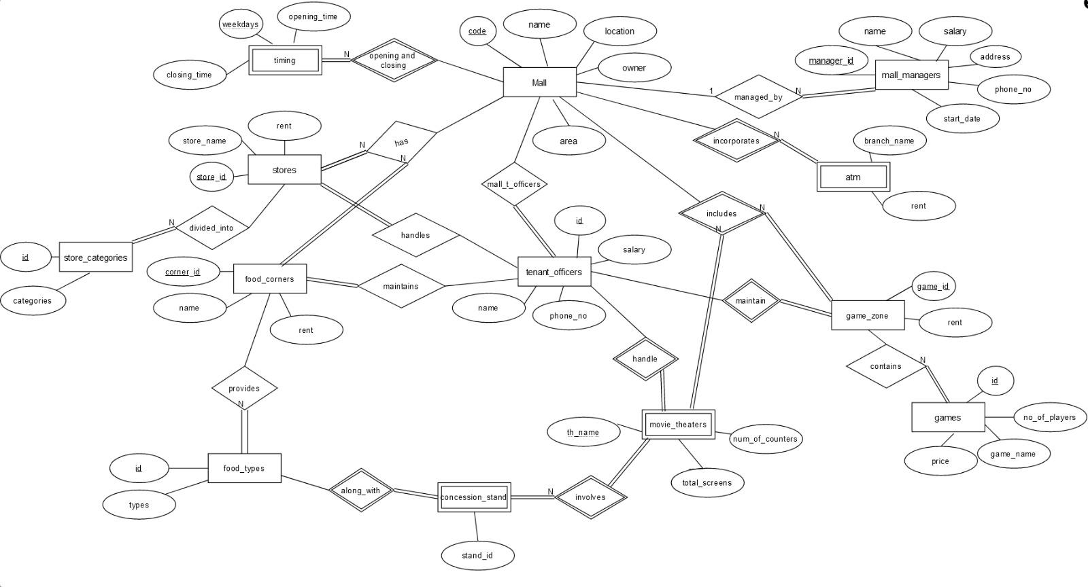

**RELATIONAL SCHEMA AFTER NORMALISATION:**

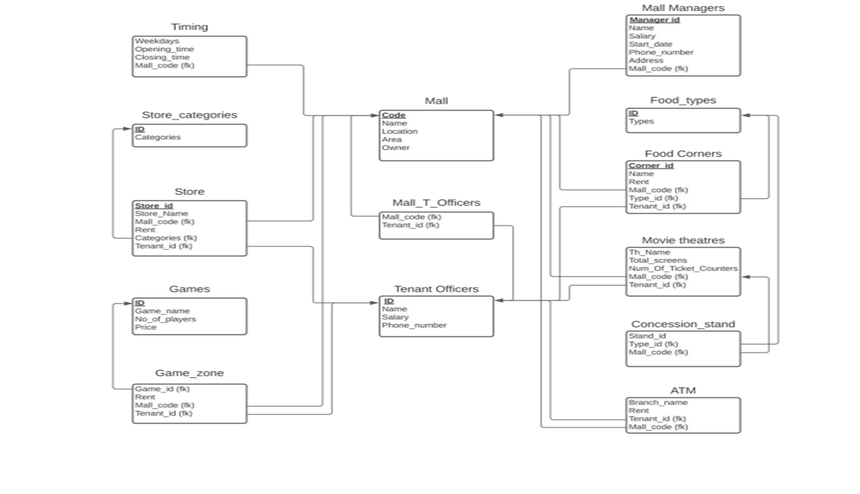

**SQL CODE:**

**1.)MALL**

**CREATE TABLE MALL**

**(CODE VARCHAR(7) PRIMARY KEY,**

**"NAME" VARCHAR(20) NOT NULL,**

**"LOCATION" VARCHAR(40) NOT NULL,**

**AREA NUMBER(8)NOT NULL,**

**OWNER VARCHAR(20)NOT NULL);**

**2.)MALL_MANAGERS**

**CREATE TABLE MALL_MANAGERS**

**(MANAGER_ID VARCHAR(5) PRIMARY KEY,**

**NAME VARCHAR(20) NOT NULL,**

**SALARY NUMBER(8)NOT NULL,**

**START_DATE DATE,**

**PHONE_NUMBER VARCHAR(10) NOT NULL,**

**ADDRESS VARCHAR(30) NOT NULL,**

**MALL_CODE VARCHAR(8) NOT NULL,**

**FOREIGN KEY(MALL_CODE) REFERENCES MALL(CODE) ON DELETE CASCADE);**

**3.)TENANT OFFICERS**

**CREATE TABLE TENANT_OFFICERS**

**(ID VARCHAR(5) PRIMARY KEY,**

**NAME VARCHAR(20) NOT NULL,**

**SALARY NUMBER(10)NOT NULL,**

**PHONE_NUMBER VARCHAR(10) NOT NULL);**

**4.)MALL_T_OFFICERS**

**CREATE TABLE MALL_T_OFFICERS**

**(MALL_CODE VARCHAR(8) NOT NULL,**

**TENANT_ID VARCHAR(5) NOT NULL,**

**FOREIGN KEY(MALL_CODE) REFERENCES MALL(CODE) ON DELETE CASCADE,**

**FOREIGN KEY(TENANT_ID) REFERENCES TENANT_OFFICERS(ID) ON DELETE CASCADE);**

**5.)TIMING**

**CREATE TABLE TIMING**

**(WEEKDAYS VARCHAR(7),**

**OPENING_TIME VARCHAR(8) NOT NULL,**

**CLOSING_TIME VARCHAR(8) NOT NULL,**

**MALL_CODE VARCHAR(8),**

**PRIMARY KEY(MALL_CODE,WEEKDAYS),**

**FOREIGN KEY(MALL_CODE) REFERENCES MALL(CODE) ON DELETE CASCADE);**

**6.)STORE_CATEGORIES**

**CREATE TABLE STORE_CATEGORIES**

**(ID VARCHAR(5) PRIMARY KEY,**

**CATEGORIES VARCHAR(20));**

**7.)STORES**

**CREATE TABLE STORES**

**(STORE_ID VARCHAR(5) PRIMARY KEY,**

**STORE_NAME VARCHAR(20)NOT NULL,**

**RENT NUMBER(8)NOT NULL,**

**TENANT_ID VARCHAR(5)NOT NULL,**

**CATEGORY_ID VARCHAR(5) NOT NULL,**

**MALL_CODE VARCHAR(8) NOT NULL,**

**FOREIGN KEY(TENANT_ID) REFERENCES TENANT_OFFICERS(ID) ON DELETE CASCADE,**

**FOREIGN KEY(CATEGORY_ID) REFERENCES CATEGORIES(ID) ON DELETE CASCADE,**

**FOREIGN KEY(MALL_CODE) REFERENCES MALL(CODE) ON DELETE CASCADE);**

**8.)FOOD_TYPES**

**CREATE TABLE FOOD_TYPES**

**(ID VARCHAR(5) PRIMARY KEY,**

**TYPES VARCHAR(20) NOT NULL);**

**9. )FOOD CORNERS**

**CREATE TABLE FOOD_CORNERS**

**(CORNER_ID VARCHAR(5) PRIMARY KEY,**

**NAME VARCHAR(20)NOT NULL,**

**RENT NUMBER(10)NOT NULL,**

**TENANT_ID VARCHAR(5)NOT NULL,**

**TYPE_ID VARCHAR(5) NOT NULL,**

**MALL_CODE VARCHAR(8) NOT NULL,**

**FOREIGN KEY(TENANT_ID) REFERENCES TENANT_OFFICERS ON DELETE CASCADE,**

**FOREIGN KEY(TYPE_ID) REFERENCES FOOD_TYPES(ID) ON DELETE CASCADE,**

**FOREIGN KEY(MALL_CODE) REFERENCES MALL ON DELETE CASCADE);**

**10.)GAMES**

**CREATE TABLE GAMES**

**(ID VARCHAR(5) PRIMARY KEY,**

**GAME_NAME VARCHAR(20) NOT NULL**

**NUM_OF_PLAYERS NUMBER(2)NOT NULL**

**PRICE NUMBER(5) NOT NULL);**

**11.)GAME_ZONECREATE TABLE GAME_ZONE**

**(GAME_ID VARCHAR(5),**

**RENT NUMBER(8) NOT NULL,**

**TENANT_ID VARCHAR(5)NOT NULL,**

**MALL_CODE VARCHAR(8),**

**PRIMARY KEY(MALL_CODE,GAME_ID),**

**FOREIGN KEY(GAME_ID) REFERENCES GAMES(ID) ON DELETE CASCADE,**

**FOREIGN KEY(TENANT_ID) REFERENCES TENANT_OFFICERS ON DELETE CASCADE,**

**FOREIGN KEY(MALL_CODE) REFERENCES MALL(CODE) ON DELETE CASCADE);**

**12.)MOVIE THEATRES**

**CREATE TABLE MOVIE_THEATRES**

**(TH_NAME VARCHAR(10) NOT NULL,**

**TOTAL_SCREENS NUMBER(2)NOT NULL,**

**NUM_OF_TICKET_COUNTERS NUMBER(2)NOT NULL,**

**RENT NUMBER(8) NOT NULL,**

**TENANT_ID VARCHAR(5)NOT NULL,**

**MALL_CODE VARCHAR(8) PRIMARY KEY,**

**FOREIGN KEY(MALL_CODE) REFERENCES MALL(CODE) ON DELETE CASCADE,**

**FOREIGN KEY(TENANT_ID) REFERENCES TENANT_OFFICERS ON DELETE CASCADE);**

**13.)CONCESSION_STAND**

**CREATE TABLE CONCESSION_STAND**

**(STAND_ID VARCHAR(5),**

**TYPE_ID VARCHAR(5),**

**MALL_CODE VARCHAR(8),**

**PRIMARY KEY(STAND_ID, MALL_CODE),**

**FOREIGN KEY(TYPE_ID) REFERENCES FOOD_TYPES(ID) ON DELETE CASCADE,**

**FOREIGN KEY(MALL_CODE) REFERENCES MOVIE_THEATRES(MALL_CODE) ON DELETE**

**CASCADE);**

**14.)ATM**

**CREATE TABLE ATM**

**(BRANCH_NAME VARCHAR(10),**

**RENT NUMBER(5) NOT NULL,**

**TENANT_ID VARCHAR(5) NOT NULL,**

**MALL_CODE VARCHAR(8),**

**PRIMARY KEY(BRANCH_NAME, MALL_CODE),**

**FOREIGN KEY(TENANT_ID) REFERENCES TENANT_OFFICERS ON DELETE CASCADE,**

**FOREIGN KEY (MALL_CODE) REFERENCES MALL(CODE) ON DELETE CASCADE);**

**INSERTION OF VALUES:**

**INSERT INTO MALL VALUES('M101', 'CITY CENTER', 'GANDHI ROAD, DELHI', 4100000, 'SIMON**

**PROPERTY GROUP');**

**INSERT INTO MALL VALUES('M102', 'AMBUJA', 'MATHURA ROAD, FARIDABAD', 5000000,**

**'KIMCO REALTY');**

**INSERT INTO MALL VALUES('M103', 'MAGNETO', 'CAMAC STREET, KOLKATA', 4953000, 'MANOJ**

**AGARWAL');**

**INSERT INTO MALL VALUES('M104', 'CITY CENTER', 'PANAJI, GOA', 6073000, 'DALIP SEHGAL');**

**INSERT INTO MALL VALUES('M105', 'COLORS', 'SHIBPUR, HOWRAH', 5550800, 'LEVIS BATA');**

**INSERT INTO MALL VALUES('M106', 'CRYSTAL', 'NEW TOWN, KOLKATA', 7300000, 'CALVIN**

**KLEIN');**

**INSERT INTO MALL VALUES('M107', 'DLF', 'SECTOR-18, NOIDA', 6580000, 'SHARYANS');**

**INSERT INTO MALL VALUES('M108', 'Z SQUARE', 'THE MALL, KANPUR', 5000000, 'RAHEJA**

**CONSTRUCTIONS');**

**INSERT INTO MALL VALUES('M109', 'HiLITE', 'KOZHIKODE BYPASS, KOZHIKODE', 8500200,**

**'HiLITE MILLS GROUP');**

**INSERT INTO MALL VALUES('M110', 'ELANTE', 'INSUSTRIAL AREA, PHASE 1, CHANDIGARH',**

**4500000, 'JINDAL CONSTRUCTIONS');**

**INSERT INTO MALL VALUES('M111', 'MAGNETO', 'WHITEFIELD MAIN ROAD, BANGALORE',**

**6700000, 'PHOENIX MILLS');**

**INSERT INTO MALL VALUES('M112', 'ESPLANADE ONE', 'RASULGARH INDUSTRIAL ESTATE,**

**BHUBANESWAR', 7106000, 'WIDITA INTERNATIONAL');**

**INSERT INTO MALL VALUES('M113', 'ORION', 'DR RAJKUMAR ROAD, BENGALURU', 8209000, 'AR**

**CONSTRUCTIONS');**

**INSERT INTO MALL VALUES('M114', 'AMBIENCE', 'DLF PHASE 3, SECTOR 24, GURUGRAM',**

**4500200, 'DLF MILLS AND GROUP');**

**INSERT INTO MALL VALUES('M115', 'THE FORUM', 'NELSON MANDELA MARG, NEW DELHI',**

**4001000, 'SKYHIGH GROUP');**

**INSERT INTO MALL_MANAGERS VALUES ('M1', 'RAJESH GUPTA', 25000, '01-JAN-2016',**

**'9876543210', 'SANEPA', 'M101');**

**INSERT INTO MALL_MANAGERS VALUES ('M2', 'ASHWINI KARKI', 35000, '11-FEB-2014',**

**'9726543221', 'RAMESHWARAM', 'M102');**

**INSERT INTO MALL_MANAGERS VALUES ('M3', 'AMIT AGARWAL', 20000, '22-MARCH-2015',**

**'9748541215', 'DURBARMARG', 'M103');**

**INSERT INTO MALL_MANAGERS VALUES ('M4', 'MUKESH GOENKA', 32000, '16-JAN-2017',**

**'9870593258', 'SUNAULI', 'M104');**

**INSERT INTO MALL_MANAGERS VALUES ('M5', 'HARSHIT BAJAJ', 25000, '01-JULY-2016',**

**'9726543219', 'RAKSHOL', 'M105');**

**INSERT INTO MALL_MANAGERS VALUES ('M6', 'PRASUN THAPA', 28000, '26-DEC-2015',**

**'9721549814', 'BIRGUNJ', 'M106');**

**INSERT INTO MALL_MANAGERS VALUES ('M7', 'RAJAT SHAKYA', 35000, '13-JUNE-2013',**

**'9851033462', 'CHAVEL', 'M107');**

**INSERT INTO MALL_MANAGERS VALUES ('M8', 'BIJESH SHARMA', 30000, '19-APRIL-2016',**

**'9818082616', 'RATOPUL', 'M108');**

**INSERT INTO MALL_MANAGERS VALUES ('M9', 'SANCHIT TIWARI', 40000, '18-JAN-2015',**

**'987148308', 'BANESHWOR', 'M109');**

**INSERT INTO MALL_MANAGERS VALUES ('M10', 'AAKASH ROY', 23000, '19-NOV-2014',**

**'9875943115', 'PATAN', 'M110');**

**INSERT INTO MALL_MANAGERS VALUES ('M11', 'BHAWESH AGRAWAL', 26000, '21-OCT-2017',**

**'9726143277', 'JAMAL', 'M111');**

**INSERT INTO MALL_MANAGERS VALUES ('M12', 'TUSHAR GOENKA', 35000, '25-JAN-2016',**

**'9716843279', 'NEWROAD', 'M112');**

**INSERT INTO MALL_MANAGERS VALUES ('M13', 'LAL KUMAR', 20000, '21-JULY-2014',**

**'9875544321', 'JAWALAKHEL', 'M113');**

**INSERT INTO MALL_MANAGERS VALUES ('M14', 'JAYESH GUPTA', 32000, '16-JUNE-2015',**

**'9806543228', 'KTM', 'M114');**

**INSERT INTO MALL_MANAGERS VALUES ('M15', 'AMIT KOERALA', 21000, '08-MAY-2016',**

**'9816543239', 'LALITPUR', 'M115');**

**INSERT INTO TENANT_OFFICERS VALUES('T101', 'AMAN BANSAL', 50000, 9996461873);**

**INSERT INTO TENANT_OFFICERS VALUES('T102', 'RASHI JAIN', 45000, 7994148473);**

**INSERT INTO TENANT_OFFICERS VALUES('T103', 'NIKITA KAPADIYA', 67000, 8796361891);**

**INSERT INTO TENANT_OFFICERS VALUES('T104', 'VISHAL SINGH', 74000, 9983446125);**

**INSERT INTO TENANT_OFFICERS VALUES('T105', 'ASIT TIWARI', 41000, 7896568147);**

**INSERT INTO TENANT_OFFICERS VALUES('T106', 'RISHI SINGHAL', 46000, 9996421873);**

**INSERT INTO TENANT_OFFICERS VALUES('T107', 'ROHIT MALHOTRA', 67000, 8316431859);**

**INSERT INTO TENANT_OFFICERS VALUES('T108', 'PRACHI SINGH', 55000, 7946211844);**

**INSERT INTO TENANT_OFFICERS VALUES('T109', 'VICKY SHARMA', 75000, 7835189358);**

**INSERT INTO TENANT_OFFICERS VALUES('T110', 'MOHIT DESAI', 80000, 9913131894);**

**INSERT INTO TENANT_OFFICERS VALUES('T111', 'KANGANA AGARWAL', 66000, 9884825854);**

**INSERT INTO TENANT_OFFICERS VALUES('T112', 'MEENA TIWARI', 64000, 6478164113);**

**INSERT INTO TENANT_OFFICERS VALUES('T113', 'AMAN SAINI', 48000, 9994284194);**

**INSERT INTO TENANT_OFFICERS VALUES('T114', 'RANBEER SINGH', 66000, 8872514571);**

**INSERT INTO TENANT_OFFICERS VALUES('T115', 'PANAKJ ROY', 55000, 6694718618);**

**INSERT INTO TENANT_OFFICERS VALUES('T116', 'SHILPA SINGH', 67000, 6247971894);**

**INSERT INTO MALL_T_OFFICERS VALUES('M101', 'T104');**

**INSERT INTO MALL_T_OFFICERS VALUES('M101', 'T106');**

**INSERT INTO MALL_T_OFFICERS VALUES('M101', 'T107');**

**INSERT INTO MALL_T_OFFICERS VALUES('M101', 'T114');**

**INSERT INTO MALL_T_OFFICERS VALUES('M101', 'T106');**

**INSERT INTO MALL_T_OFFICERS VALUES('M102', 'T103');**

**INSERT INTO MALL_T_OFFICERS VALUES('M102', 'T105');**

**INSERT INTO MALL_T_OFFICERS VALUES('M102', 'T108');**

**INSERT INTO MALL_T_OFFICERS VALUES('M102', 'T109');**

**INSERT INTO MALL_T_OFFICERS VALUES('M102', 'T113');**

**INSERT INTO MALL_T_OFFICERS VALUES('M103', 'T104');**

**INSERT INTO MALL_T_OFFICERS VALUES('M103', 'T107');**

**INSERT INTO MALL_T_OFFICERS VALUES('M103', 'T110');**

**INSERT INTO MALL_T_OFFICERS VALUES('M104', 'T112');**

**INSERT INTO MALL_T_OFFICERS VALUES('M104', 'T113');**

**INSERT INTO MALL_T_OFFICERS VALUES('M104', 'T111');**

**INSERT INTO MALL_T_OFFICERS VALUES('M104', 'T116');**

**INSERT INTO MALL_T_OFFICERS VALUES('M105', 'T105');**

**INSERT INTO MALL_T_OFFICERS VALUES('M105', 'T106');**

**INSERT INTO MALL_T_OFFICERS VALUES('M105', 'T109');**

**INSERT INTO MALL_T_OFFICERS VALUES('M106', 'T101');**

**INSERT INTO MALL_T_OFFICERS VALUES('M106', 'T108');**

**INSERT INTO MALL_T_OFFICERS VALUES('M107', 'T103');**

**INSERT INTO MALL_T_OFFICERS VALUES('M107', 'T106');**

**INSERT INTO MALL_T_OFFICERS VALUES('M107', 'T107');**

**INSERT INTO MALL_T_OFFICERS VALUES('M107', 'T108');**

**INSERT INTO MALL_T_OFFICERS VALUES('M108', 'T111');**

**INSERT INTO MALL_T_OFFICERS VALUES('M108', 'T112');**

**INSERT INTO MALL_T_OFFICERS VALUES('M109', 'T105');**

**INSERT INTO MALL_T_OFFICERS VALUES('M109', 'T108');**

**INSERT INTO MALL_T_OFFICERS VALUES('M109', 'T109');**

**INSERT INTO MALL_T_OFFICERS VALUES('M110', 'T104');**

**INSERT INTO MALL_T_OFFICERS VALUES('M110', 'T113');**

**INSERT INTO MALL_T_OFFICERS VALUES('M111', 'T107');**

**INSERT INTO MALL_T_OFFICERS VALUES('M111', 'T108');**

**INSERT INTO MALL_T_OFFICERS VALUES('M111', 'T111');**

**INSERT INTO MALL_T_OFFICERS VALUES('M111', 'T114');**

**INSERT INTO MALL_T_OFFICERS VALUES('M112', 'T104');**

**INSERT INTO MALL_T_OFFICERS VALUES('M112', 'T108');**

**INSERT INTO MALL_T_OFFICERS VALUES('M113', 'T102');**

**INSERT INTO MALL_T_OFFICERS VALUES('M113', 'T109');**

**INSERT INTO MALL_T_OFFICERS VALUES('M113', 'T110');**

**INSERT INTO MALL_T_OFFICERS VALUES('M114', 'T101');**

**INSERT INTO MALL_T_OFFICERS VALUES('M114', 'T106');**

**INSERT INTO MALL_T_OFFICERS VALUES('M114', 'T108');**

**INSERT INTO MALL_T_OFFICERS VALUES('M114', 'T113');**

**INSERT INTO MALL_T_OFFICERS VALUES('M115', 'T115');**

**INSERT INTO MALL_T_OFFICERS VALUES('M115', 'T116');**

**INSERT INTO TIMING VALUES ('MTWTF', '10:00 AM', '6:00 PM', 'M101');**

**INSERT INTO TIMING VALUES ('MTWTFS', '09:00 AM', '7:00 PM', 'M102');**

**INSERT INTO TIMING VALUES ('SMTWTF', '10:30 AM', '8:00 PM', 'M103');**

**INSERT INTO TIMING VALUES ('MTTFS', '11:00 AM', '6:30 PM', 'M104');**

**INSERT INTO TIMING VALUES ('SMTWFS', '09:30 AM', '7:30 PM', 'M105');**

**INSERT INTO TIMING VALUES ('SMWTF', '10:00 AM', '5:30 PM', 'M106');**

**INSERT INTO TIMING VALUES ('MWTFS', '11:30 AM', '4:00 PM', 'M107');**

**INSERT INTO TIMING VALUES ('SMTWTFS', '12:00 AM', '6:00 PM', 'M108');**

**INSERT INTO TIMING VALUES ('SMTTS', '09:00 AM', '5:30 PM', 'M109');**

**INSERT INTO TIMING VALUES ('STWTFS', '10:40 AM', '7:00 PM', 'M110');**

**INSERT INTO TIMING VALUES ('SMTWTS', '09:40 AM', '8:00 PM', 'M111');**

**INSERT INTO TIMING VALUES ('SMTWTF', '11:30 AM', '7:30 PM', 'M112');**

**INSERT INTO TIMING VALUES ('MTWTFS', '12:00 AM', '8:30 PM', 'M113');**

**INSERT INTO TIMING VALUES ('SMWTS', '11:00 AM', '9:00 PM', 'M114');**

**INSERT INTO TIMING VALUES ('MTTFS', '10:50 AM', '10:00 PM', 'M115');**

**INSERT INTO STORE_CATEGORIES VALUES('S100','GROCERY');**

**INSERT INTO STORE_CATEGORIES VALUES('S101','FURNITURES');**

**INSERT INTO STORE_CATEGORIES VALUES('S102','CLOTHING');**

**INSERT INTO STORE_CATEGORIES VALUES('S103','ACCESSORIES');**

**INSERT INTO STORE_CATEGORIES VALUES('S104','PHARMACY');**

**INSERT INTO STORE_CATEGORIES VALUES('S105','SERVICE STATIONS');**

**INSERT INTO STORE_CATEGORIES VALUES('S106','ELECTRONICS');**

**INSERT INTO STORE_CATEGORIES VALUES('S107','JEWELLERY');**

**INSERT INTO STORE_CATEGORIES VALUES('S108','STATIONARY');**

**INSERT INTO STORE_CATEGORIES VALUES('S109','FOOTWEARS');**

**INSERT INTO STORE_CATEGORIES VALUES('S110','PET');**

**INSERT INTO STORE_CATEGORIES VALUES('S111','DEPARTMENT');**

**INSERT INTO STORES VALUES('SI201', 'ARROWS', 5300, 'T106','S101', 'M101');**

**INSERT INTO STORES VALUES('SI202', 'SHOPULSE', 4500, 'T104','S111', 'M101');**

**INSERT INTO STORES VALUES('SI203', 'SPEED APPAREL', 6200, 'T105','S103', 'M102');**

**INSERT INTO STORES VALUES('SI204', 'SMILE LOVES', 6300, 'T110','S105', 'M103');**

**INSERT INTO STORES VALUES('SI205', 'BESTMART', 5900, 'T104','S101', 'M103');**

**INSERT INTO STORES VALUES('SI206', 'BUY YOUR DREAM', 5400, 'T107','S109', 'M103');**

**INSERT INTO STORES VALUES('SI207', 'SHOPNEST', 4400, 'T112','S104', 'M104');**

**INSERT INTO STORES VALUES('SI208', 'LIBERTY LAND', 5300, 'T113','S108', 'M104');**

**INSERT INTO STORES VALUES('SI209', 'WALK IN WONDERS', 5500, 'T105','S103', 'M105');**

**INSERT INTO STORES VALUES('SI210', 'DRESSY GIRLZ', 6200, 'T105','S102', 'M105');**

**INSERT INTO STORES VALUES('SI211', 'FAST PACED', 5100, 'T108','S107', 'M106');**

**INSERT INTO STORES VALUES('SI212', 'JIVE SHOP', 4500, 'T101','S106', 'M106');**

**INSERT INTO STORES VALUES('SI213', 'BUYNOW', 4700, 'T108','S111', 'M107');**

**INSERT INTO STORES VALUES('SI214', 'SHOP HOP', 4800, 'T107','S103', 'M107');**

**INSERT INTO STORES VALUES('SI215', 'FRESH FOOD', 6300, 'T112','S101', 'M108');**

**INSERT INTO STORES VALUES('SI216', 'MALLTUDE', 7200, 'T108','S105', 'M109');**

**INSERT INTO STORES VALUES('SI217', 'BESTBUY', 6300, 'T109','S109', 'M109');**

**INSERT INTO STORES VALUES('SI218', 'GREEN SHOP', 6600, 'T109','S101', 'M109');**

**INSERT INTO STORES VALUES('SI219', 'SUNLIVES', 5700, 'T113','S104', 'M110');**

**INSERT INTO STORES VALUES('SI220', 'THE CORNER SHOP', 5300, 'T111','S106', 'M111');**

**INSERT INTO STORES VALUES('SI221', 'MYSHOP', 5500, 'T111','S108', 'M111');**

**INSERT INTO STORES VALUES('SI222', 'GOODSHOP', 7500, 'T108','S109', 'M112');**

**INSERT INTO STORES VALUES('SI223', 'BUZZSHOP', 7200, 'T104','S105', 'M112');**

**INSERT INTO STORES VALUES('SI224', 'LUXURY LINES', 6400, 'T102','S102', 'M113');**

**INSERT INTO STORES VALUES('SI225', 'THREADS AND BLOOMS', 5200, 'T110','S102', 'M113');**

**INSERT INTO STORES VALUES('SI226', 'BLUE SHELVES', 6900, 'T110','S108', 'M113');**

**INSERT INTO STORES VALUES('SI227', 'GIFTS AND GLAM', 7100, 'T113','S103', 'M114');**

**INSERT INTO STORES VALUES('SI228', 'XSHOP', 5700, 'T115','S101', 'M115');**

**INSERT INTO STORES VALUES('SI229', 'THE ROYAL REALITY', 4200, 'T116','S107', 'M115');**

**INSERT INTO FOOD_TYPES VALUES('FT101','RESTAURANT');**

**INSERT INTO FOOD_TYPES VALUES('FT102','CAFE');**

**INSERT INTO FOOD_TYPES VALUES('FT103','ICE CREAM PARLOUR');**

**INSERT INTO FOOD_TYPES VALUES('FT104','FOOD STALLS');**

**INSERT INTO FOOD_TYPES VALUES('FT105','BAKERY');**

**INSERT INTO FOOD_TYPES VALUES('FT106','JUICE SHOP');**

**INSERT INTO FOOD_CORNERS VALUES('FC101','MCDONALDS',6000,'T104','FT101','M101');**

**INSERT INTO FOOD_CORNERS VALUES('FC102','DREAMY CREAMY',3500,'T112','FT103','M104');**

**INSERT INTO FOOD_CORNERS VALUES('FC103','BHEL PURI',2000,'T108','FT104','M109');**

**INSERT INTO FOOD_CORNERS VALUES('FC104','DOMINOS PIZZA',6500,'T113','FT101','M102');**

**INSERT INTO FOOD_CORNERS VALUES('FC105','JUICE MASTERS',3000,'T106','FT106','M114');**

**INSERT INTO FOOD_CORNERS VALUES('FC106','AMUL',4000,'T107','FT105','M107');**

**INSERT INTO FOOD_CORNERS VALUES('FC107','BASKIN-ROBBINS',4000,'T105','FT103','M105');**

**INSERT INTO FOOD_CORNERS VALUES('FC108','PIZZA HUT',6000,'T107','FT101','M103');**

**INSERT INTO FOOD_CORNERS VALUES('FC109','CANDY SHOP',2000,'T104','FT104','M110');**

**INSERT INTO FOOD_CORNERS VALUES('FC110','NATURALS',3000,'T116','FT106','M115');**

**INSERT INTO FOOD_CORNERS VALUES('FC111','VERKA MILK',4000,'T112','FT105','M108');**

**INSERT INTO FOOD_CORNERS VALUES('FC112','KFC',8000,'T111','FT101','M104');**

**INSERT INTO FOOD_CORNERS VALUES('FC113','CCD',6000,'T101','FT102','M106');**

**INSERT INTO FOOD_CORNERS VALUES('FC114','CAKE INDUSTRY',5000,'T109','FT105','M109');**

**INSERT INTO FOOD_CORNERS VALUES('FC115','NESCAFE',2500,'T103','FT102','M107');**

**INSERT INTO FOOD_CORNERS VALUES('FC116','FUN FOOD',3000,'T108','FT104','M111');**

**INSERT INTO FOOD_CORNERS VALUES('FC117','JUICE MASTERS',4000,'T106','FT106','M101');**

**INSERT INTO FOOD_CORNERS VALUES('FC118','DOMINOS PIZZA',6000,'T109','FT101','M105');**

**INSERT INTO FOOD_CORNERS VALUES('FC119','BRU',2500,'T111','FT102','M108');**

**INSERT INTO FOOD_CORNERS VALUES('FC120','CREAM VILLA',4500,'T113','FT103','M110');**

**INSERT INTO FOOD_CORNERS VALUES('FC121','CRUNCHY BALLS',3500,'T104','FT104','M112');**

**INSERT INTO FOOD_CORNERS VALUES('FC122','AMUL',5500,'T107','FT105','M111');**

**INSERT INTO FOOD_CORNERS VALUES('FC123','TROPICANA',4500,'T105','FT106','M102');**

**INSERT INTO FOOD_CORNERS VALUES('FC124','CCD',5000,'T110','FT102','M113');**

**INSERT INTO FOOD_CORNERS VALUES('FC125','BASKIN-ROBBINS',4000,'T115','FT103','M115');**

**INSERT INTO FOOD_CORNERS VALUES('FC126','KFC',8000,'T101','FT101','M106');**

**INSERT INTO FOOD_CORNERS VALUES('FC127','NESCAFE',2500,'T113','FT102','M110');**

**INSERT INTO FOOD_CORNERS VALUES('FC128','MCDONALDS',6000,'T102','FT101','M113');**

**INSERT INTO FOOD_CORNERS VALUES('FC129','NATURALS',3000,'T104','FT106','M103');**

**INSERT INTO FOOD_CORNERS VALUES('FC130','AMUL',5500,'T108','FT105','M112');**

**INSERT INTO GAMES VALUES(G101,'CAR DASH',10,250);**

**INSERT INTO GAMES VALUES(G102,'BOWLING',6,500);**

**INSERT INTO GAMES VALUES(G103,'LAZER CASTLE',8,300);**

**INSERT INTO GAMES VALUES(G104,'VR REAL CRICKET',2,600);**

**INSERT INTO GAMES VALUES(G105,'PLAYBOX KIDS',6,200);**

**INSERT INTO GAMES VALUES(G106,'TABLE TENNIS',2,150);**

**INSERT INTO GAMES VALUES(G107,'ARCADE BASKETBALL',2,200);**

**INSERT INTO GAMES VALUES(G108,'DART GAMES',2,150);**

**INSERT INTO GAMES VALUES(G109,'8 BALL POOL',2,150);**

**INSERT INTO GAMES VALUES(G110,'PLAY STATION',6,100);**

**INSERT INTO GAMES VALUES(G111,'MOTO GP',1,250);**

**INSERT INTO GAMES VALUES(G112,'GUN GAME',1,250);**

**INSERT INTO GAMES VALUES(G113,'AIR HOCKEY',2,300);**

**INSERT INTO GAMES VALUES(G114,'TABLE FOOTBALL',4,100);**

**INSERT INTO GAMES VALUES(G115,'SHOOTING',1,300);**

**INSERT INTO GAME_ZONE VALUES(G101,4450,T104,M112);**

**INSERT INTO GAME_ZONE VALUES(G110,4000,T111,M108);**

**INSERT INTO GAME_ZONE VALUES(G111,3350,T105,M102);**

**INSERT INTO GAME_ZONE VALUES(G104,4320,T109,M109);**

**INSERT INTO GAME_ZONE VALUES(G101,4050,T116,M104);**

**INSERT INTO GAME_ZONE VALUES(G106,3450,T106,M107);**

**INSERT INTO GAME_ZONE VALUES(G102,4000,T110,M113);**

**INSERT INTO GAME_ZONE VALUES(G105,4554,T114,M101);**

**INSERT INTO GAME_ZONE VALUES(G103,2950,T108,M111);**

**INSERT INTO GAME_ZONE VALUES(G113,5450,T115,M115);**

**INSERT INTO GAME_ZONE VALUES(G112,4720,T107,M103);**

**INSERT INTO GAME_ZONE VALUES(G104,4523,T113,M110);**

**INSERT INTO GAME_ZONE VALUES(G102,3650,T101,M114);**

**INSERT INTO GAME_ZONE VALUES(G113,3780,T108,M112);**

**INSERT INTO GAME_ZONE VALUES(G115,3500,T106,M105);**

**INSERT INTO GAME_ZONE VALUES(G107,4455,T110,M103);**

**INSERT INTO GAME_ZONE VALUES(G109,4000,T108,M106);**

**INSERT INTO GAME_ZONE VALUES(G108,3250,T113,M114);**

**INSERT INTO GAME_ZONE VALUES(G114,3400,T107,M101);**

**INSERT INTO GAME_ZONE VALUES(G111,3000,T108,M112);**

**INSERT INTO GAME_ZONE VALUES(G106,5100,T104,M103);**

**INSERT INTO GAME_ZONE VALUES(G112,4000,T103,M102);**

**INSERT INTO GAME_ZONE VALUES(G115,4050,T109,M105);**

**INSERT INTO GAME_ZONE VALUES(G107,4350,T104,M101);**

**INSERT INTO GAME_ZONE VALUES(G109,4850,T109,M109);**

**INSERT INTO MOVIE_THEATRES VALUES('PVR',8,3,15000,'T107','M101');**

**INSERT INTO MOVIE_THEATRES VALUES('INOX',5,2,12000,'T105','M102');**

**INSERT INTO MOVIE_THEATRES VALUES('PVR',7,4,15000,'T116','M104');**

**INSERT INTO MOVIE_THEATRES VALUES('CINEWORLD',9,3,17000,'T105','M106');**

**INSERT INTO MOVIE_THEATRES VALUES('PATHE',6,2,18000,'T107','M108');**

**INSERT INTO MOVIE_THEATRES VALUES('HOYTS',8,2,19000,'T109','M109');**

**INSERT INTO MOVIE_THEATRES VALUES('INOX',5,1,14000,'T104','M110');**

**INSERT INTO MOVIE_THEATRES VALUES('INOX',7,3,14000,'T108','M111');**

**INSERT INTO MOVIE_THEATRES VALUES('CINEPLEX',8,2,16000,'T110','M113');**

**INSERT INTO MOVIE_THEATRES VALUES('CINEWORLD',7,4,17000,'T113','M114');**

**INSERT INTO CONCESSION_STAND VALUES('ST201','FT103','M101');**

**INSERT INTO CONCESSION_STAND VALUES('ST202','FT104','M101');**

**INSERT INTO CONCESSION_STAND VALUES('ST201','FT106','M102');**

**INSERT INTO CONCESSION_STAND VALUES('ST201','FT104','M104');**

**INSERT INTO CONCESSION_STAND VALUES('ST202','FT103','M104');**

**INSERT INTO CONCESSION_STAND VALUES('ST203','FT104','M104');**

**INSERT INTO CONCESSION_STAND VALUES('ST201','FT104','M106');**

**INSERT INTO CONCESSION_STAND VALUES('ST202','FT106','M106');**

**INSERT INTO CONCESSION_STAND VALUES('ST201','FT103','M108');**

**INSERT INTO CONCESSION_STAND VALUES('ST201','FT104','M109');**

**INSERT INTO CONCESSION_STAND VALUES('ST201','FT103','M110');**

**INSERT INTO CONCESSION_STAND VALUES('ST202','FT106','M110');**

**INSERT INTO CONCESSION_STAND VALUES('ST201','FT106','M111');**

**INSERT INTO CONCESSION_STAND VALUES('ST201','FT104','M113');**

**INSERT INTO CONCESSION_STAND VALUES('ST201','FT103','M114');**

**INSERT INTO CONCESSION_STAND VALUES('ST202','FT104','M114');**

**INSERT INTO ATM VALUES('SBI',9000,'T106','M101');**

**INSERT INTO ATM VALUES('HDFC',9000,'T107','M101');**

**INSERT INTO ATM VALUES('ICICI',9000,'T109','M102');**

**INSERT INTO ATM VALUES('SBI',9000,'T104','M103');**

**INSERT INTO ATM VALUES('YES',9000,'T111','M104');**

**INSERT INTO ATM VALUES('KOTAK',9000,'T105','M105');**

**INSERT INTO ATM VALUES('HDFC',9000,'T109','M105');**

**INSERT INTO ATM VALUES('PNB',9000,'T108','M107');**

**INSERT INTO ATM VALUES('CBI',9000,'T105','M109');**

**INSERT INTO ATM VALUES('ICICI',9000,'T108','M109');**

**INSERT INTO ATM VALUES('YES',9000,'T113','M110');**

**INSERT INTO ATM VALUES('PNB',9000,'T104','M112');**

**INSERT INTO ATM VALUES('PNB',9000,'T110','M113');**

**INSERT INTO ATM VALUES('KOTAK',9000,'T102','M113');**

**INSERT INTO ATM VALUES('SBI',9000,'T115','M115');**

**SQL QUERIES:**

**1)Retrieve the details of movie theaters along with their associated tenant officers and mall details**

**QUERY:**

**SELECT MT., TO.*, M.FROM MOVIE_THEATRES MTJOIN TENANT_OFFICERS TO ON MT.TENANT_ID = TO.IDJOIN MALL M ON MT.MALL_CODE = M.CODE;**

**OUTPUT:**

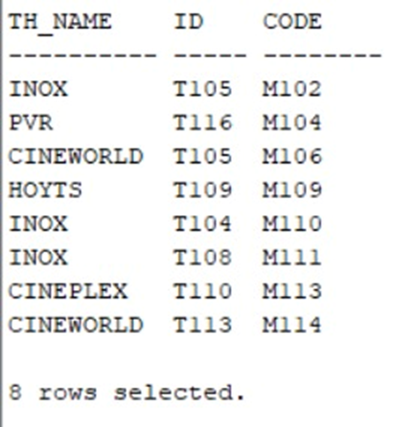

**2)Retrieve the details of all stores in a specific mall along with their corresponding category**

**Query:**

**SELECT S.store_name, SC.CATEGORIES FROM STORES SJOIN STORE_CATEGORIES SC ON S.CATEGORY_ID = SC.IDWHERE S.MALL_CODE = 'M106';**

**OUTPUT:**

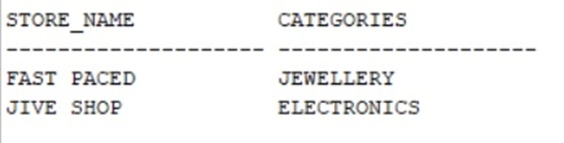

**3)Retrieve the details of all mall managers along with their corresponding mall details**

**Query:**

**SELECT MM."NAME",MM.MANAGER_ID, M.CODEFROM MALL_MANAGERS MMJOIN MALL M ON MM.MALL_CODE = M.CODE;**

**OUTPUT:**

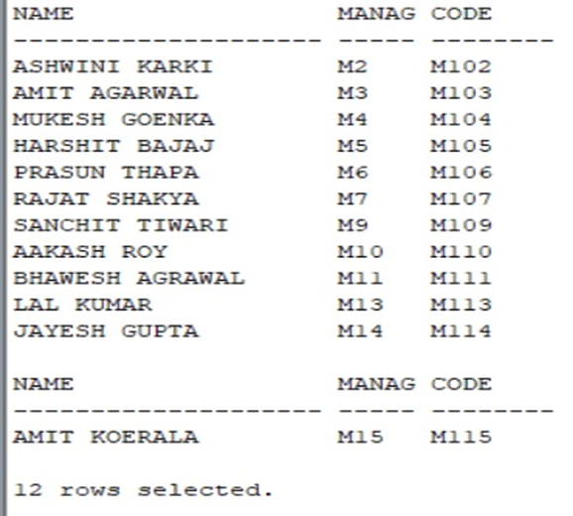

**4)Retrieve the names of all mall managers along with the count of stores they manage**

**Query:**

**SELECT MM.NAME, COUNT(S.STORE_ID) AS STORE_COUNTFROM MALL_MANAGERS MMLEFT JOIN MALL M ON MM.MALL_CODE = M.CODE LEFT JOIN STORES S ON M.CODE = S.MALL_CODEGROUP BY MM.NAME;**

**OUTPUT:**

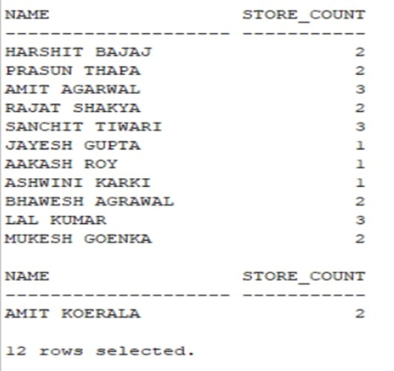

**5)Retrieve the names of tenant officers who work in both food corners and movie theaters**

**Query:**

**SELECT TOF."NAME"FROM TENANT_OFFICERS TOF JOIN FOOD_CORNERS FC ON TOF."ID" = FC.TENANT_IDJOIN MOVIE_THEATRES MT ON TOF."ID" = MT.TENANT_ID;**

**OUTPUT:**

